User Guide

Body:

Add Channel:

To add a channel, click on the button in the top right labelled “Add channel”. When clicking you will be prompted to set the name of the channel, this can be left blank and the channel will give itself a name based on its position on the mixing desk.

Play/Pause Buttons:

The play and pause buttons are located in the top right of the screen, the “play” button plays and the “pause” button pauses playback.

Tempo:

To change the playback tempo of all sequences, use the slider in the top middle of the screen labelled “tempo”. This has a limited range of between 10 and 250 bpm. 

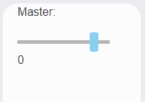Master Volume:

The master volume control is located in its own container in the lower left of the screen, this lowers volume of the output from all channels.

Sequencer:

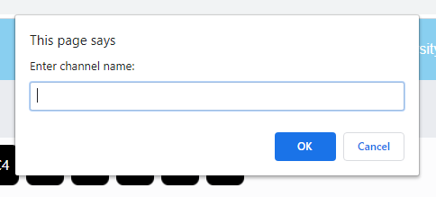Renaming channel:

To rename a channel click on the name in the channel or the name in the sequencer, when your cursor turns into a text cursor, and you will be prompted by a box where you can type in your new name.

**Notes:**

Playing a Note:

To set a note in the sequence to play click on the black squares in the sequencer, when set to play the square will show up as light blue.

Changing note:

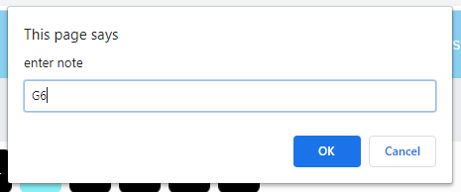To change the note that will be played at the given point hover over the step and click the middle mouse button, you will be prompted to input the note you want (notes are to be input in the following notation: C4, A3, F#5...etc).

**Opening Synth Options:**

To open the synth options menu double click on the white space around the sequencer and it will open a Menu underneath.

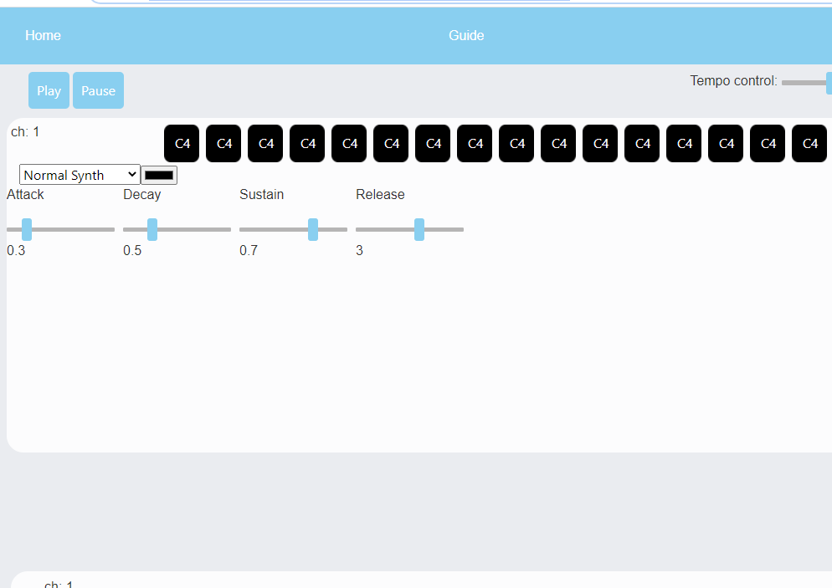

Synth Type:

In the Synth settings there is a drop-down menu that shows the name of the current synth, to change synth click on the menu and choose which type you want.

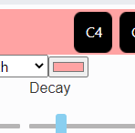Colour:

Adjacent to the synth selection menu there is a rectangle with a colour in the middle witch is black by default, to change channel colour click on the box and choose which colour you like (the colour input will be different for different browsers).

Envelope:

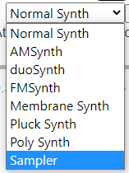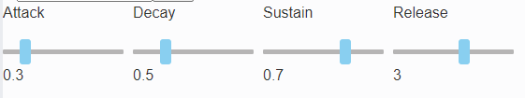Below synth and colour selection there are four sliders which control the Attack, Decay, Sustain and release values of each given synth (each synth will store its own envelope values).

Sampler:

To access the sampler, open the synth selection menu, the sampler will be the bottom most option. Simply click on this option and the channel source will change to the sampler.

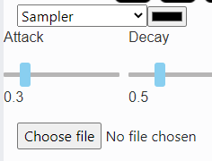Adding Samples:

To add a sample to the sampler, click on the button bellow the synth options menu that says “choose file”. This will open a file dialog where you can select which audio file you would like to use.

Pitch Shifting Samples:

To change the playback pitch of a sample, change the value of the note being played by middle clicking on a step and the sample will automatically change pitch relative to the difference from the default note value (C4-middle c).

Allowed Audio File Types:

.mp3, .wav.

Mixing Desk:

Renaming channel:

To rename a channel click on the name in the channel or the name in the sequencer and you will be prompted by a box where you can type in your new name.

Volume, Pan and Mute:

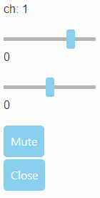Controls for these are found in the mixing desk channel displayed along the bottom.

* The first slider is volume which uses decibels and has a range between -60 ~ 20.
* The second slider is the channel pan, which is middle by default, move it left to have the sound be placed more in the left speaker and vice versa.

The mute button is placed just below these sliders and is labelled “mute” clicking this will stop the source from playing sound.

Close Channel:

To delete the channel, click on the button labelled “close” at the bottom of the mixing desk channel.

Desk Channel Colour:

Adjacent to the synth selection menu in the sequencer there is a rectangle with a colour in the middle witch is black by default, to change channel colour click on the box and choose which colour you like (the colour input will be different for different browsers).

**Opening Effects Menu:**

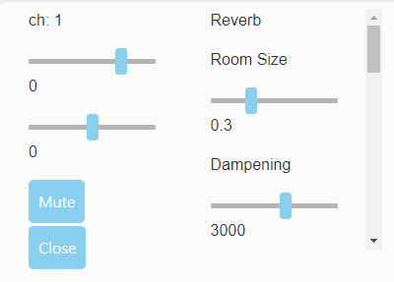To open the effects menu for each channel, double-click on the white space of a channel and it will open a scrollable menu to the right of it.

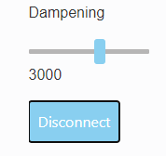Adding Effects:

To add an effect to the signal path, click the connect button bellow the effect’s options.

Ordering Effects:

Effects are added in the order that you press the connect button. If you disconnect and reconnect an effect that is in between others in the path it will be added to the end of the signal path and be connected to the master.